A statement such as @title = “Home”  in this case creating a new variable @title with *value* "Home".

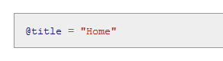

The at sign @ in@title indicates that it is an instance variable.  
Instance variables have a more general meaning in Ruby, but in Rails their role is primarily to link actions and views: any instance variable defined in the **home** action is automatically available in the **home.html.erb** view, and so on for other action/view pairs.  
In fact, the instance variable is actually visible in any view, a fact we’ll make use of in Section 8.2.2.